MD on Beam Scope Window Shavers – Summary (MD6 user)

Monday 6 October 2014:

Beam type: MD_160MeV_WBSshaving_2014_Clone

2 turns injected into ring 2

MD were performed at the 160 MeV flat top. Intensity, emittances and orbit were measured. Shaving efficiency were observed for the different current in range of 0.5 up to 6A (every 0.5A) at DBSV7 and DBSV9. We managed to get 1micron emittance beam (V plane) -> to be follow up.

Some results:

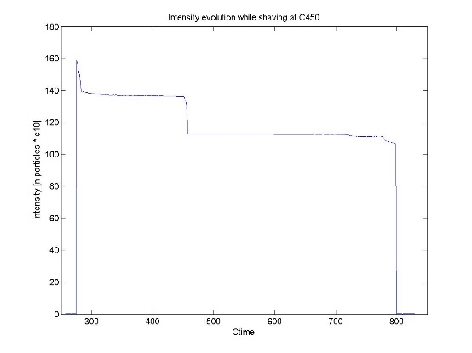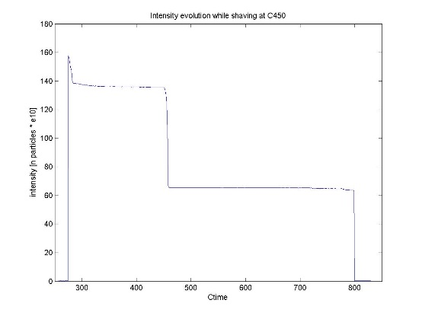

Intensity drop due to shaving with I = 5 A and I = 6 A at DSBV7 and DSBV9



Longitudinal shape of the measured beam

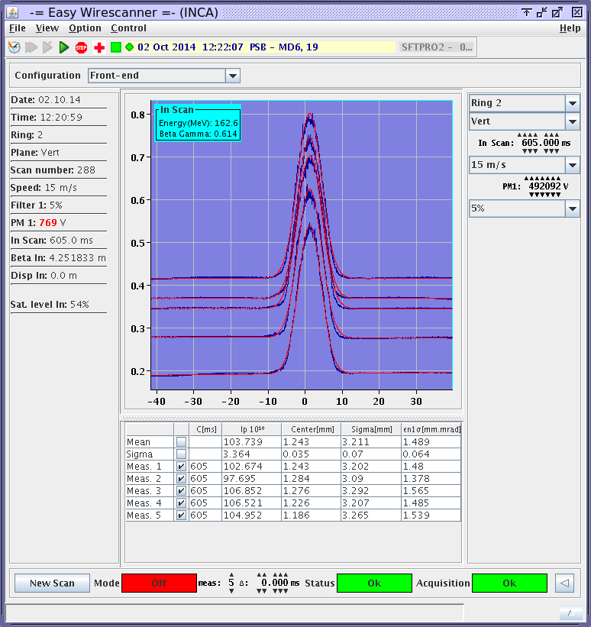

Example of the measured beam profile

Thursday 9 October 2014:

Beam type: MD_50MeV_WBS_shaving (copy of EAST beam)

2 turns injected into ring 3

MD were performed at the 65 MeV ramp. The goal was to reproduce the existing shaving in operation with the WBS shavers. Intensity, emittances and orbit were measured. Shaving efficiency were observed for the different current in range of 2.8 up to 3.2A (every 0.1A) at DBSV7 and DBSV9. Next step will be to perform the same MDs with the corrected orbit.

EB & MK