**Tune Shift Measurements at 160 MeV**

MD Report - Week 46

B Jones, K Li, C Zannini

**Tuesday 11th November**

Data was taken for all four rings. However there was a problem with the Q-Meter application and the kick in rings 1,2 & 4 was very small or zero. The results are shown below.

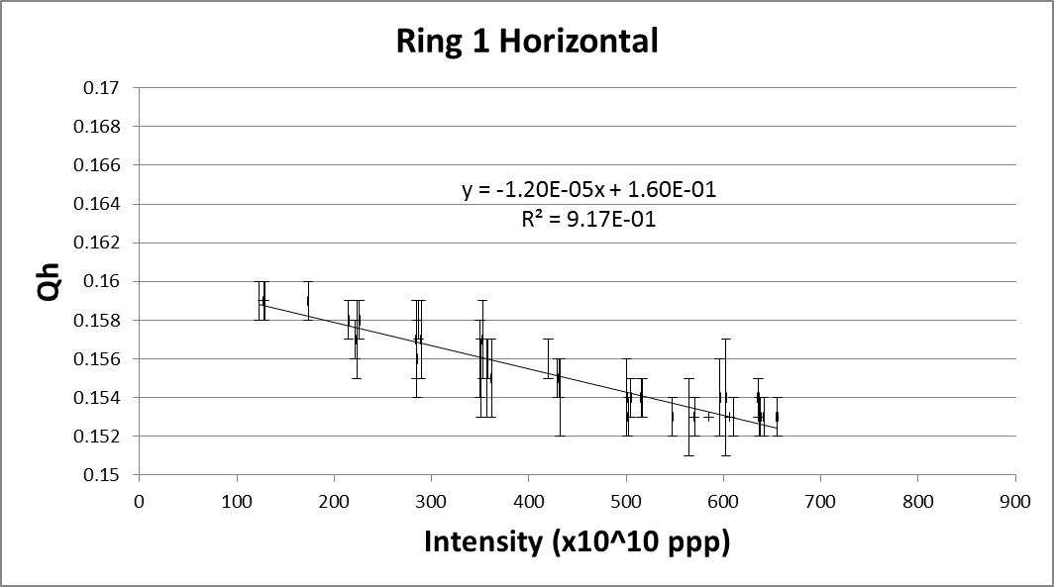 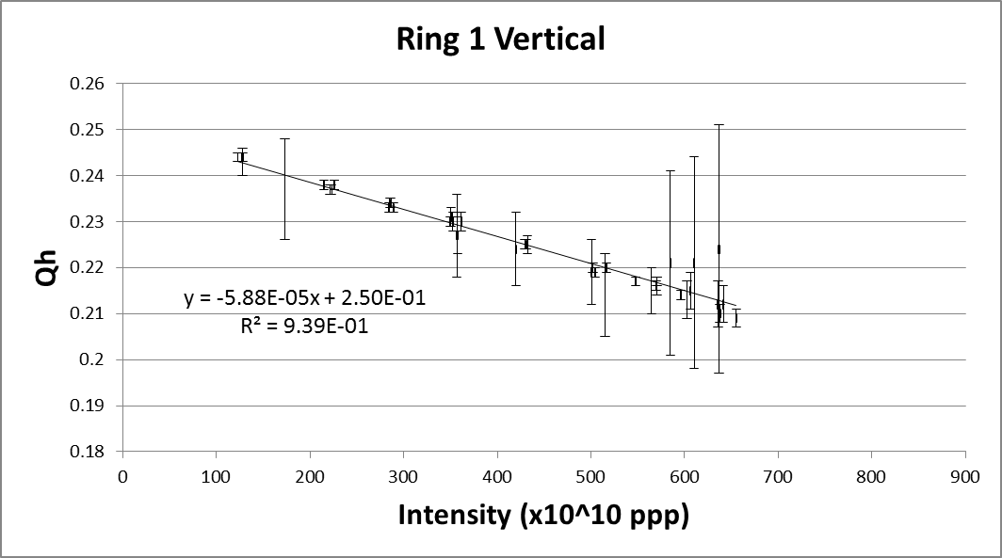 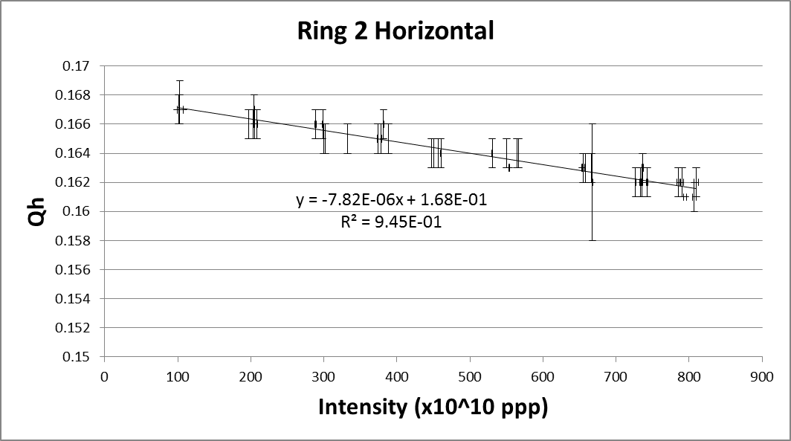 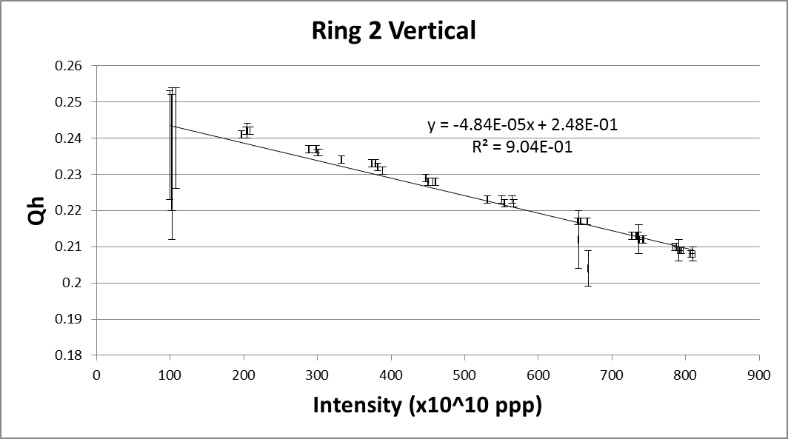 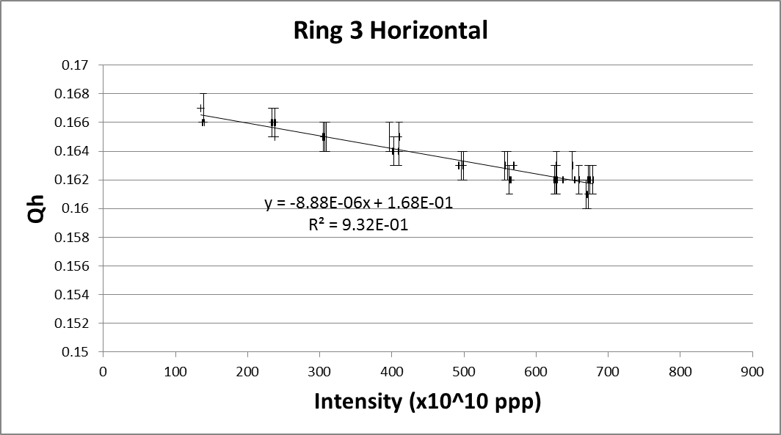 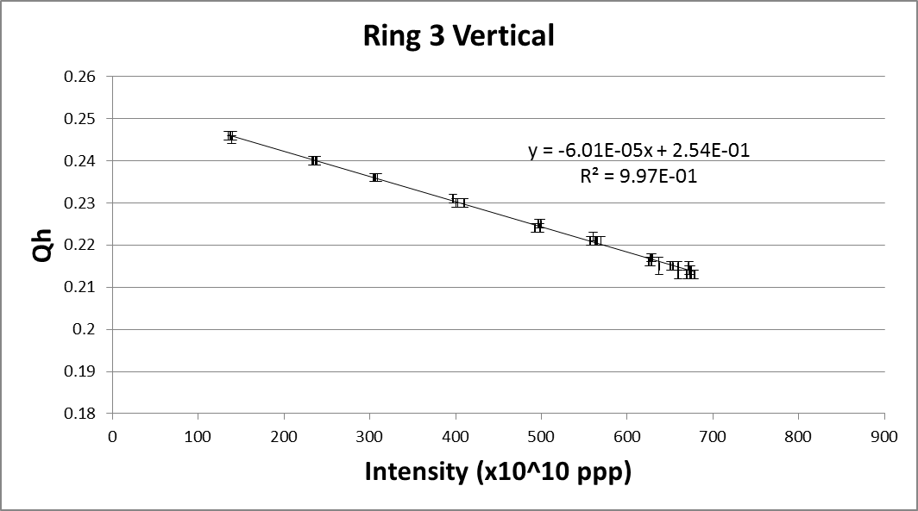 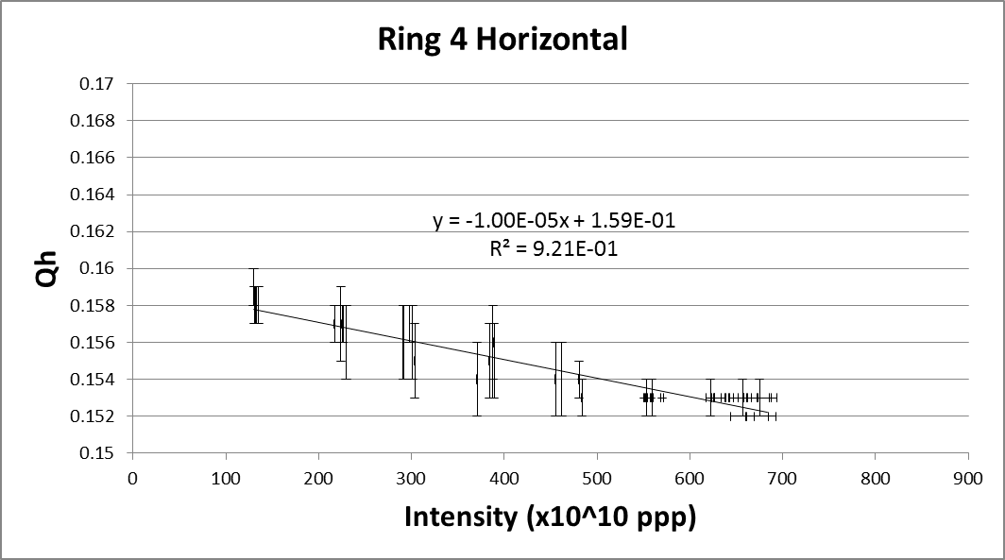 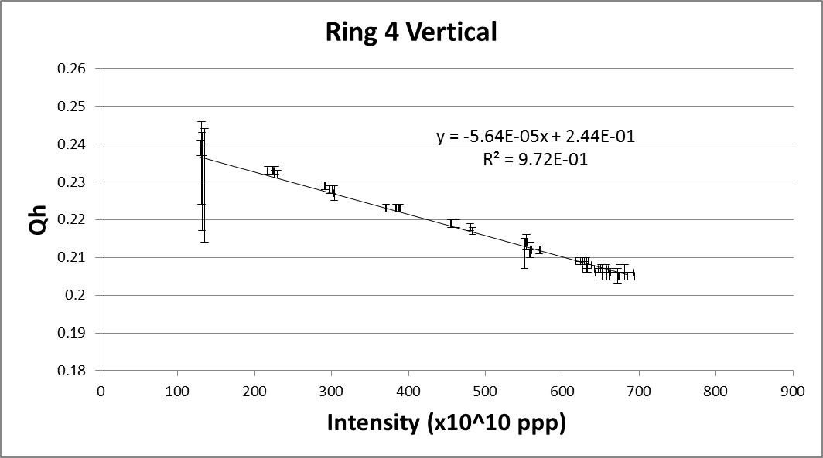

Summary of results from 11/11/14-

|  |  |  |  |  |
| --- | --- | --- | --- | --- |
|  | **Horizontal** | | **Vertical** | |
|  | **ΔQ (x10-5)** | **Qo** | **ΔQ (x10-5)** | **Qo** |
| **Ring 1** | -1.20 | 0.160 | -5.88 | 0.250 |
| **Ring 2** | -0.78 | 0.168 | -5.68 | 0.248 |
| **Ring 3** | -0.89 | 0.168 | -6.01 | 0.254 |
| **Ring 4** | -1.00 | 0.159 | -5.64 | 0.244 |

**Friday 14th November 2014**

Measurements on all rings were repeated.

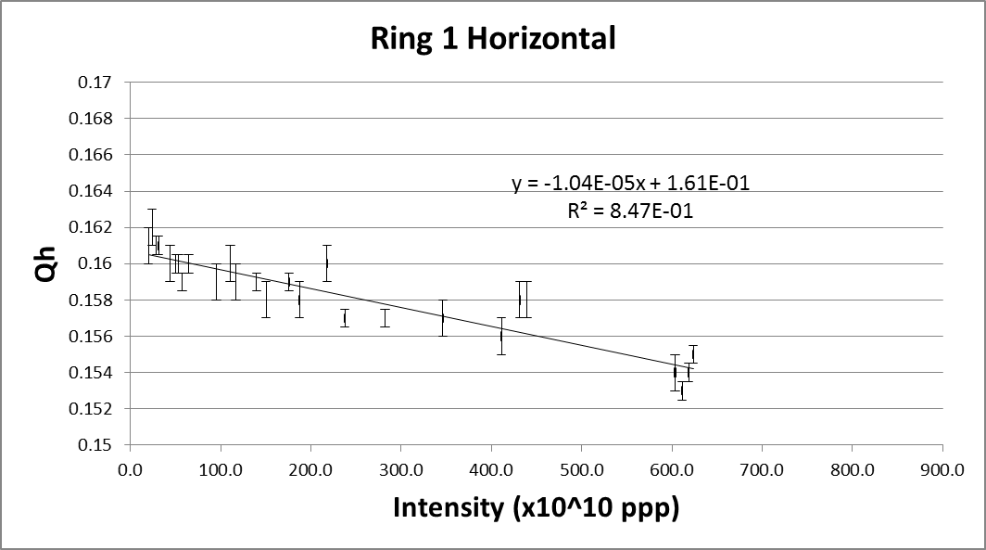 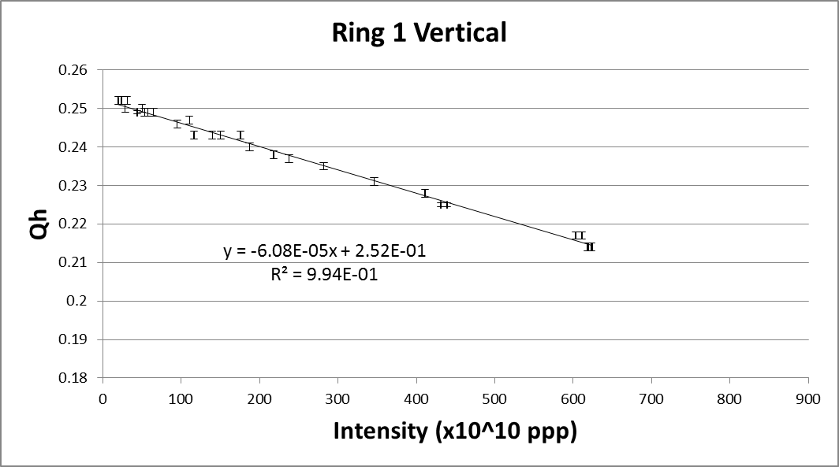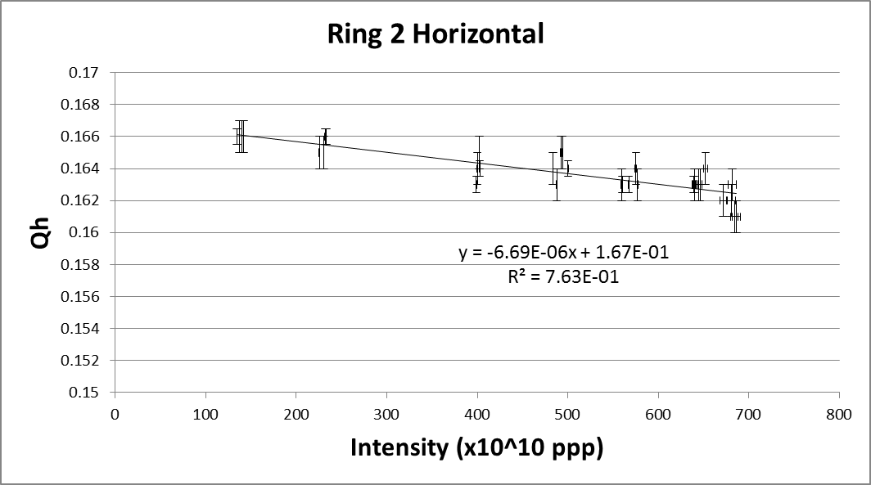 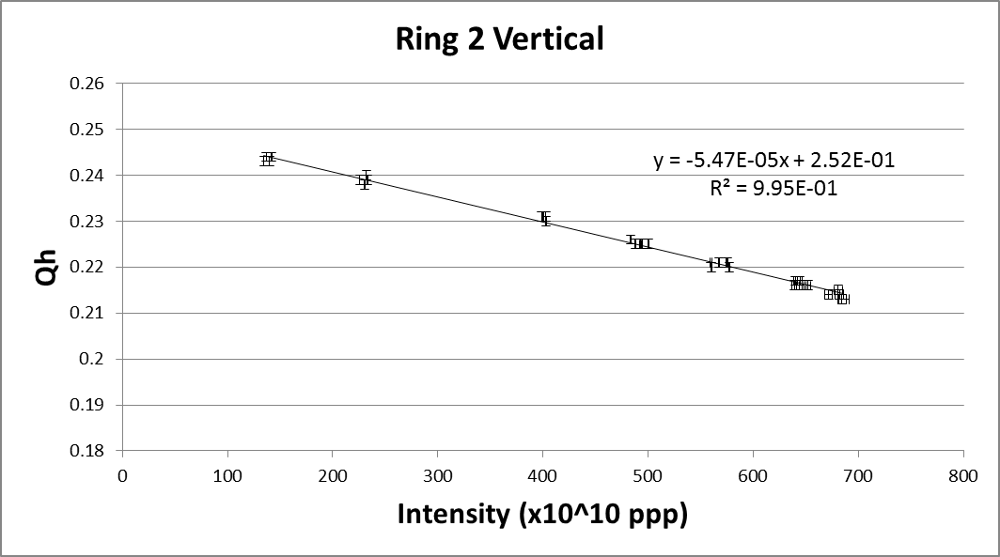

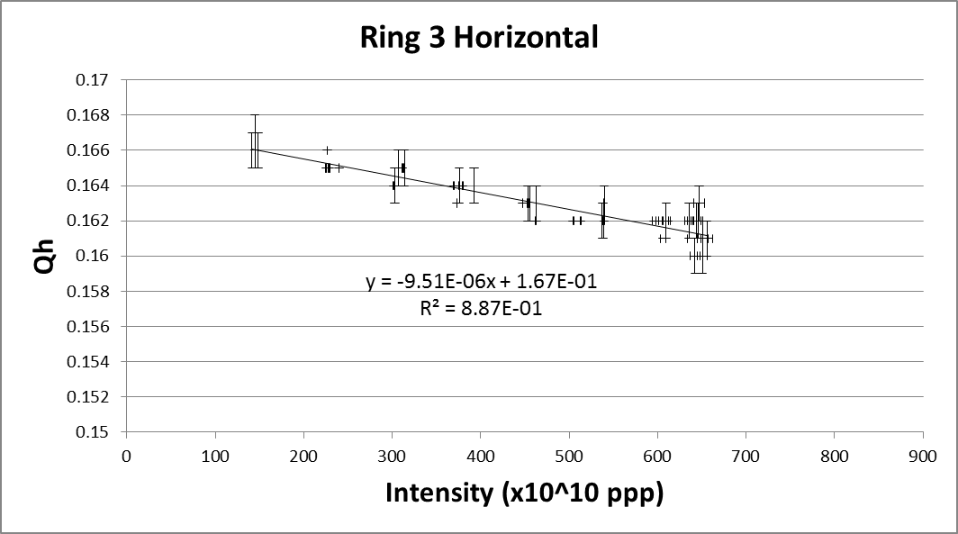 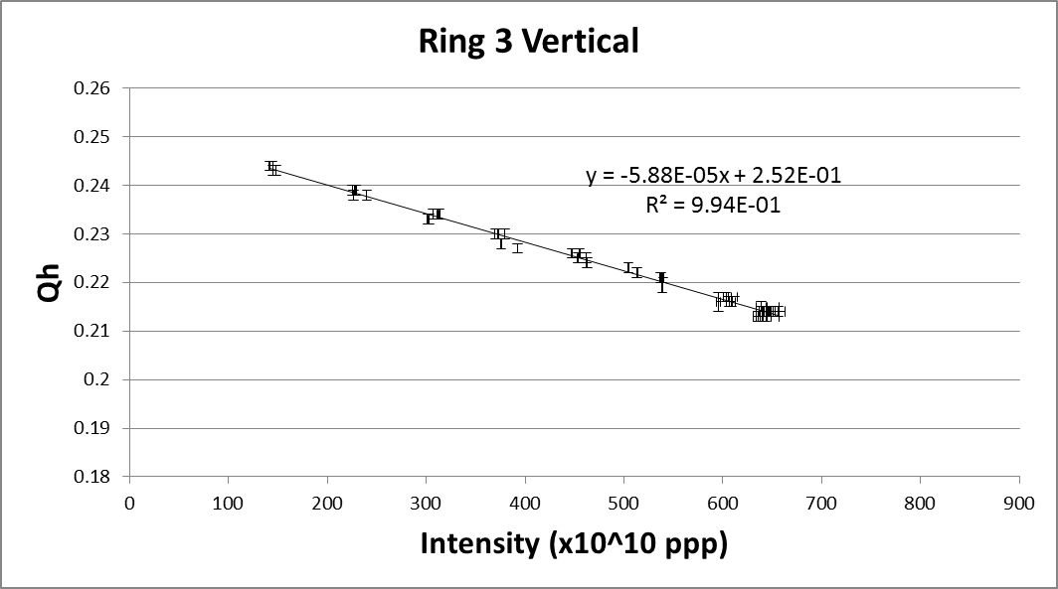

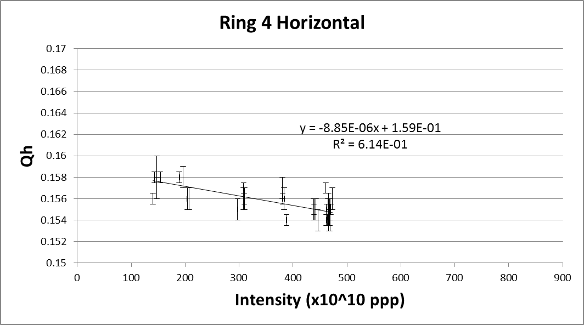 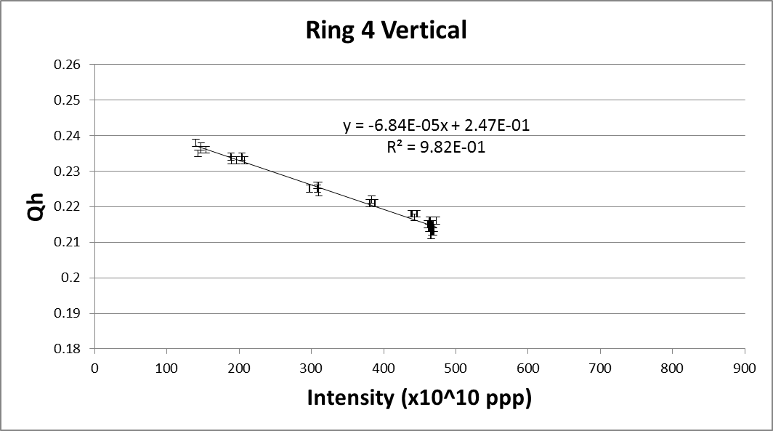

Summary of results from 14/11/14-

|  |  |  |  |  |
| --- | --- | --- | --- | --- |
|  | **Horizontal** | | **Vertical** | |
|  | **ΔQ (x10-5)** | **Qo** | **ΔQ (x10-5)** | **Qo** |
| **Ring 1** | -1.04 | 0.161 | -6.08 | 0.252 |
| **Ring 2** | -0.67 | 0.167 | -5.47 | 0.252 |
| **Ring 3** | -0.95 | 0.167 | -5.88 | 0.252 |
| **Ring 4** | -0.89 | 0.159 | -6.84 | 0.247 |

A preliminary data analysis of the full set of measurements for each ring seems to indicate that Ring 2 has the lowest effective impedance in both transverse planes. However, a more detailed data analysis accounting also for the dependence of bunch length on beam intensity will be performed for better comparisons. We now move to measurements at higher energy.