**Space Charge Measurements at 60 MeV**

MD Report - Week 48

B Jones, E Benedetto

**Wednesday 26th November**

A new cycle named ‘MD_SPACECHARGE_60MeV’ was created for studies of space charge effects at low energy. Starting from a clone of the 160 MeV cycle, the B field was edited to plateau at 60 MeV.

Jean-Michel further optimised the cycle to give a 62MeV flat-top and 46MeV ‘extraction’. And by adjusting the tunes and orbit corrector functions beam was successfully stored over the flat-top.

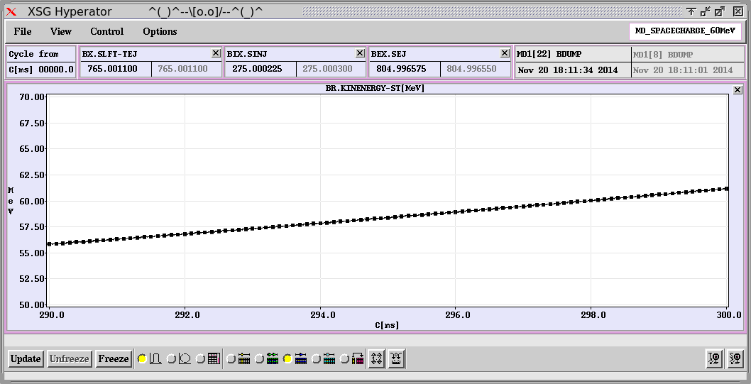 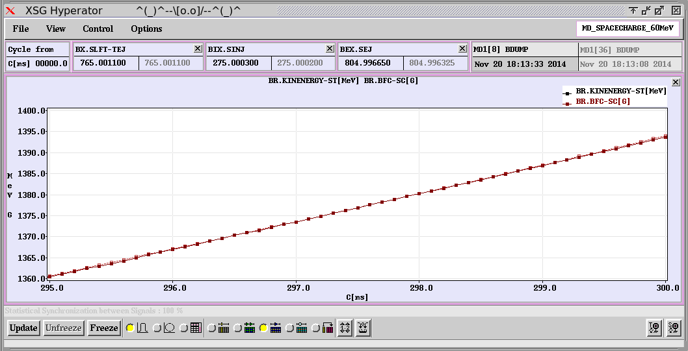 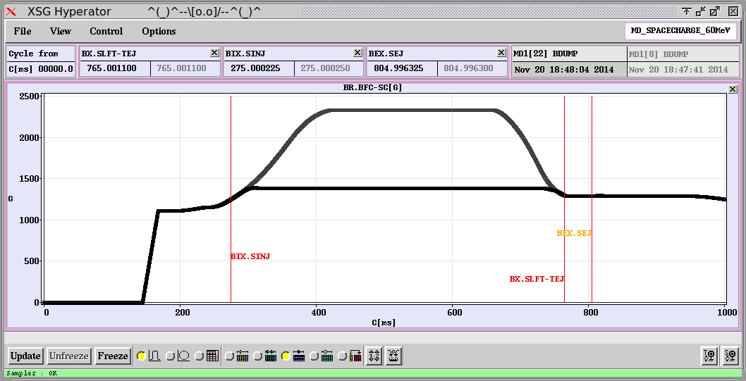 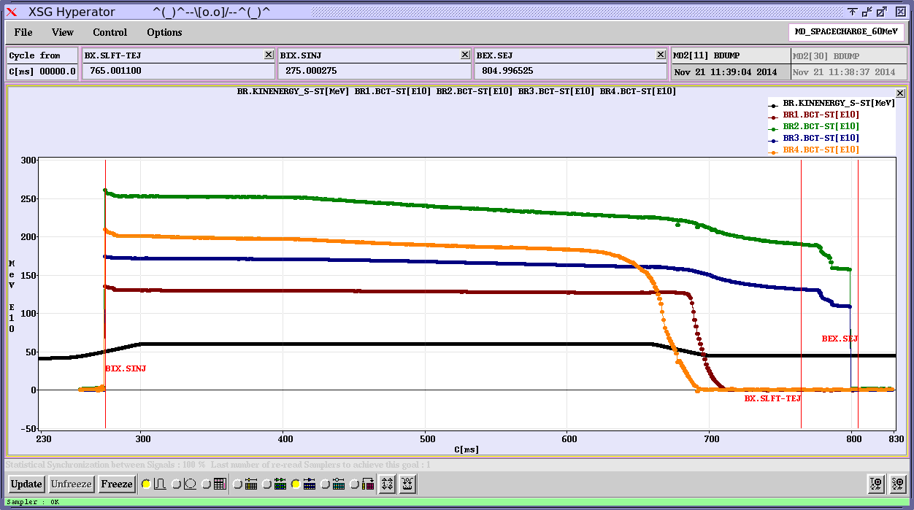

**60MeV is reached at C298, B Field is 1380G.**

Tune plane scans were performed on ring 2 for 3 injected turns (~200E10 ppb). The transverse emittances measured with the wire scanners were ε1σ h,v = 5.7, 4.2 μm.rad. Only single-harmonic RF was applied and the bunch length was 850-900 ns. From these measurements we can predict a tune shift of ~0.6.

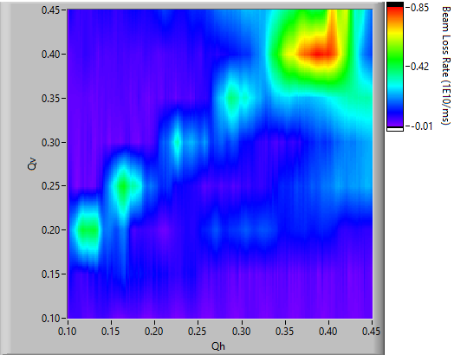 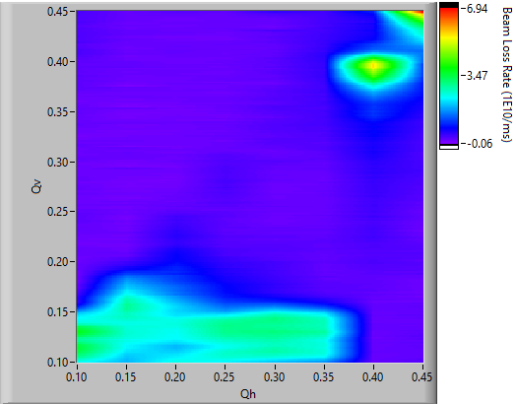

**Scans of increasing Qh (left) and decreasing Qv (right) at 60 MeV**

The scans do not show resonances along all the lines expected from 160 MeV scans, perhaps due to the large tune spread. Future measurements could reduce the tune spread using anti-phased C04 RF and a lower beam intensity.