**Tune Shift Measurements at 1.4 GeV**

MD Report - Week 48

B Jones, C Zannini

**Tuesday 25th November**

Data was taken for rings 2 and 3 at 1.4 GeV using an ISOGPS clone with updated orbit correction settings. Only the vertical plane was measured as previous results had shown the horizontal tune shift is too small to measure at this energy. The measurements were made from C765 to C785 on the 1.4 GeV extraction plateau – avoiding the extraction bump ramp which seemed to affect the tune measurements last time. The results are shown below.

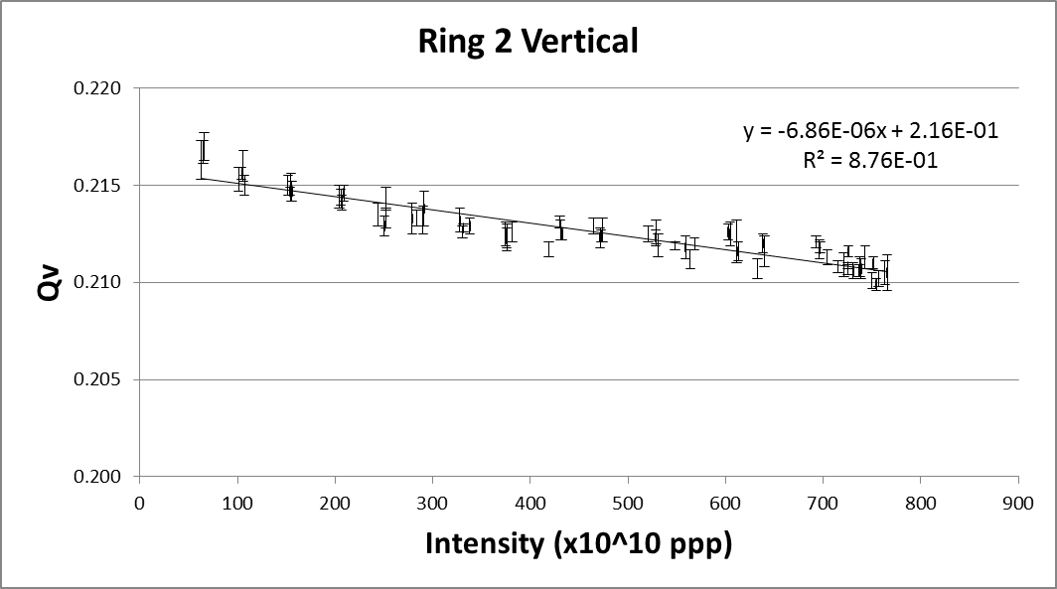 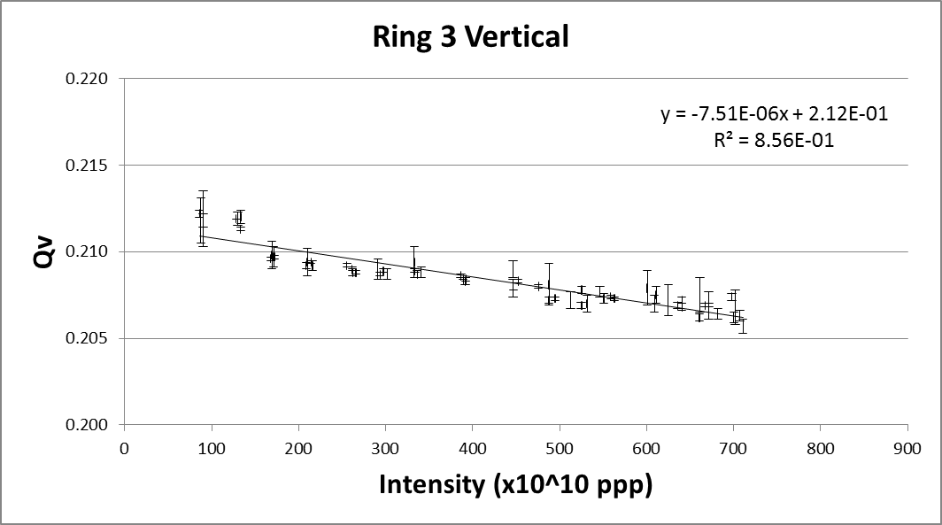

The tune shift response is not quite linear, the cause of this perturbation is not known. The bunch length was measured throughout each scan but the results do not explain this observed variation in tune.

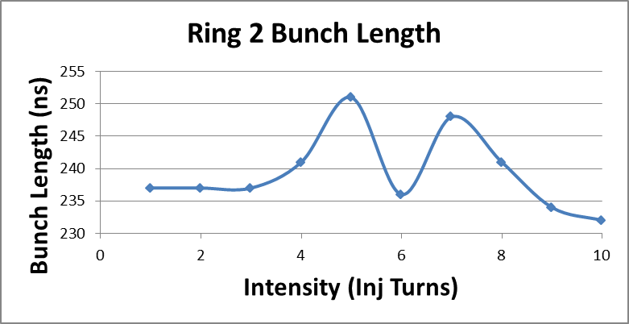 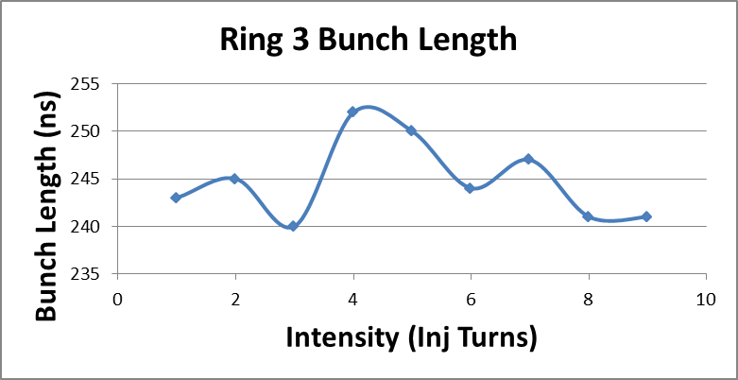

The results are consistent with previous measurements by D Quatraro (below). Future studies could check the stability of the beam energy, programmed tune, and bunch length to try to explain these results.

