**Tune Shift Measurements at 1.4 GeV**

MD Report - Week 49

B Jones, K Li, C Zannini

**Monday 1st December**

Data was taken for rings 1 and 4 to complete the measurements at 1.4 GeV. Again, only the vertical plane was measured as previous results had shown the horizontal tune shift is too small to measure at this energy. The measurements were made from C765 to C775 on the 1.4 GeV extraction plateau – avoiding the horizontal extraction bump ramp. The results are shown below.

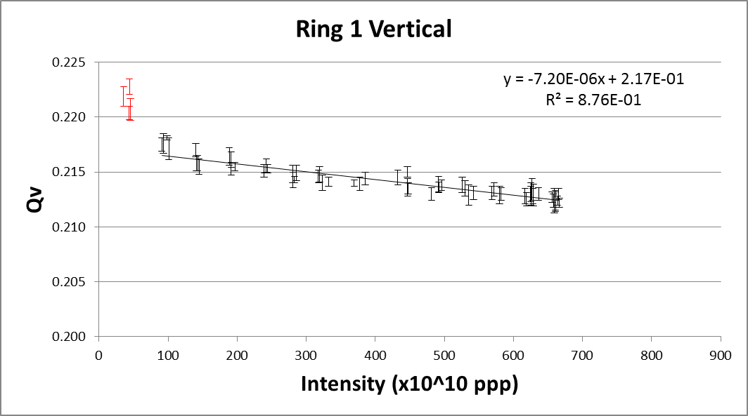 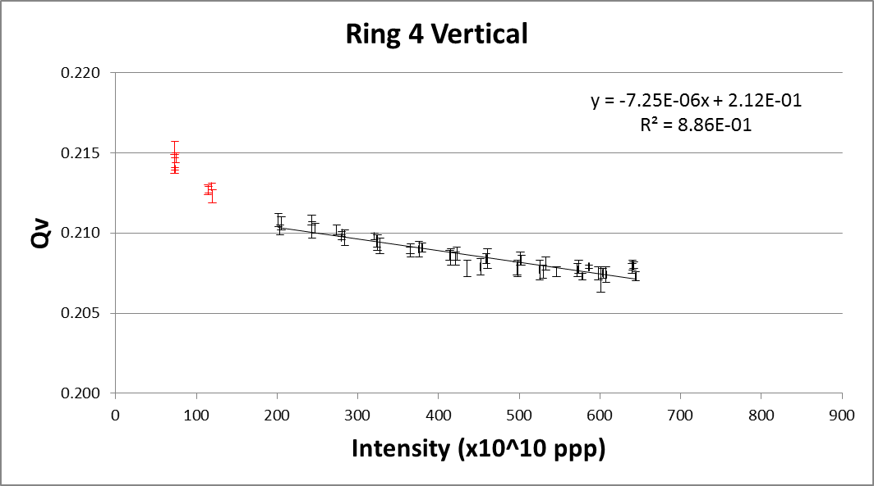

The low intensity measurements do not show the expected linear response and have therefore been excluded from the linear fits shown on the plots.

A summary of the measured vertical tune shift values at 1.4 GeV is given below:

|  |  |  |
| --- | --- | --- |
|  | **Vertical** | |
|  | **ΔQ (x10-6 per 1E10 ppb)** | **Qo** |
| **Ring 1** | -7.20 | 0.217 |
| **Ring 2** | -6.86 | 0.216 |
| **Ring 3** | -7.51 | 0.212 |
| **Ring 4** | -7.25 | 0.212 |